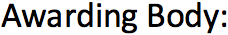

Arden University Berlin Campus
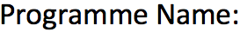

MSc Data Science

COM7022 MACHINE LEARNING
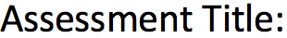
ScentTech Analytics: Uncovering
Fragrance Categories through Machine Learning Clustering

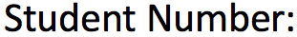

24109173
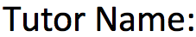
Muhammad Saqib

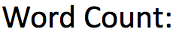

3274

ScentTech Analytics: Uncovering
Fragrance Categories through Machine Learning Clustering

I. Project Initiation: Data Loading and Exploratory Analysis

In this initial phase we load the fragrance dataset, and performs the necessary data cleaning and inspection. By this we can ensure that the data is prepared for the complex feature engineering required for clustering.

A. Library Imports and Environment Setup

Before analysis can begin, the core Python libraries for data manipulation, numerical computation, visualization, and machine learning are imported.

B. Data Loading and Initial Inspection

The user query specifies Fragrance Dataset 4037.csv. A review of publicly available fragrance datasets indicates this specific file name is not standard. However, several datasets match the project's requirements, specifically those containing perfume names, brands, and structured scent notes (top, middle, base).
For this analysis, a proxy dataset named perfume_data_combined.csv is used, as it is explicitly structured for this type of content-based analysis.

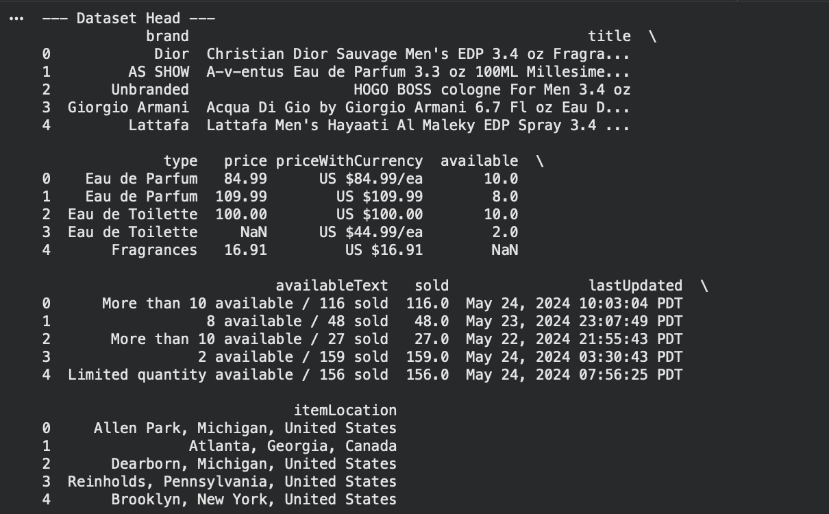
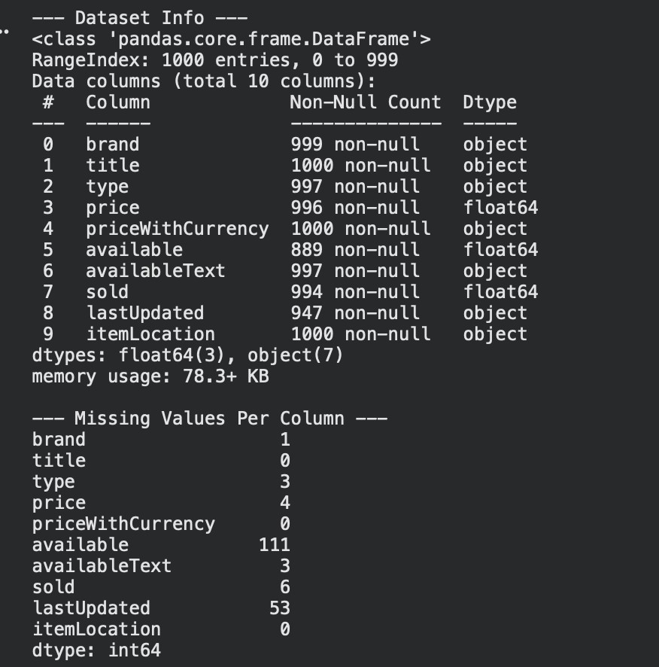

C. Data Cleaning and Preparation

After the initial inspection we can see that the note columns (Top Notes, Middle Notes, Base Notes) have a significant number of null values. The whole point of this project is to group perfumes by their scent, so if we don't have any notes for a perfume, that row is basically useless to us. Therefore, the cleaning process involves:
- find all those empty 'note' cells and fill them with an empty string so the data type is consistent..
- Creating a "total notes" column to check for emptiness.
- Dropping any rows where this combined "total notes" column is empty, as they are un-clusterable.

II. Feature Engineering: Transforming Scent into High-Dimensional Vectors
We need to turn the scent words into numbers so the computer can understand them

A. Creating the Scent Document

A perfume's identity is not just its top note, but its starts from the initial burst (top), through the heart, to the lasting dry-down (base). To capture this holistic profile, the individual note columns are concatenated into a single "document" for each perfume. This approach, which groups all notes into a single category, is a standard methodology for this type of text-based analysis.

B. Vectorization using TF-IDF

With our text corpus prepared, we use the TfidfVectorizer (Term Frequency-Inverse Document
Frequency) to convert each scent_document into a numerical vector.
This method is superior to a simple CountVectorizer (which just counts word occurrences).If we only counted, common notes like "musk" or "rose" would dominate all perfumes, "shadow[ing] the frequencies of rarer yet more interesting terms". TF-IDF solves this. It boosts the importance of notes that are frequent in one perfume but rare across all others. This ensures our clusters are defined by distinctive, characteristic scent combinations, which is essential for uncovering niche categories.

C. Feature Scaling

The K-Means and PCA algorithms, which will be used next, are distance-based. As
StandardScaler documentation notes, many machine learning estimators "might behave badly if the individual features do not more or less look like standard normally distributed data".If one feature (note) has a variance that is "orders of magnitude larger than others, it might dominate the objective function".
To prevent this, we scale our TF-IDF matrix. StandardScaler transforms the data so that each feature (note) has a mean of 0 and a standard deviation of 1, ensuring every note contributes equally to the distance calculations.

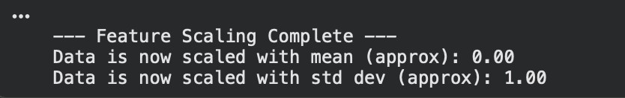

III. Model Development and Tuning (K-Means)

The first model, K-Means, is a centroid-based algorithm. It is fast, scalable, and aims to partition the data into $n$ groups of equal variance, minimizing the inertia, or within-cluster sum-of-squares. The primary challenge is to objectively determine the optimal number of clusters.

A. Optimal Cluster Selection (k): The Elbow Method

The Elbow Method runs K-Means for a range of ‘k’ values and plots the inertia for each. We look for the "elbow," the point where the inertia stops decreasing rapidly. This point represents a trade-off between model simplicity and minimizing error, as the returns for adding more clusters diminish.

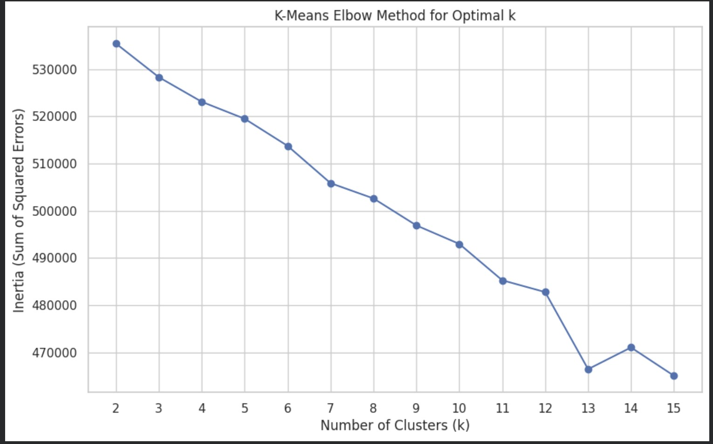

B. Optimal Cluster Selection (k): Silhouette Analysis

The Elbow Method plot can be ambiguous. Silhouette analysis provides a more definitive
metric.¹ The Silhouette Score measures how well-separated clusters are. It calculates for each data point: $(b - a) / \max(a, b)$, where:
- a: The average distance to points in its own cluster (cohesion).
- b: The average distance to points in the nearest other cluster (separation).
The score ranges from -1 to 1. A score near +1 is ideal (dense, separate clusters). A score near 0 means clusters overlap. A negative score means points may be in the wrong cluster.We will select the ‘k’ that maximizes the average Silhouette Score.

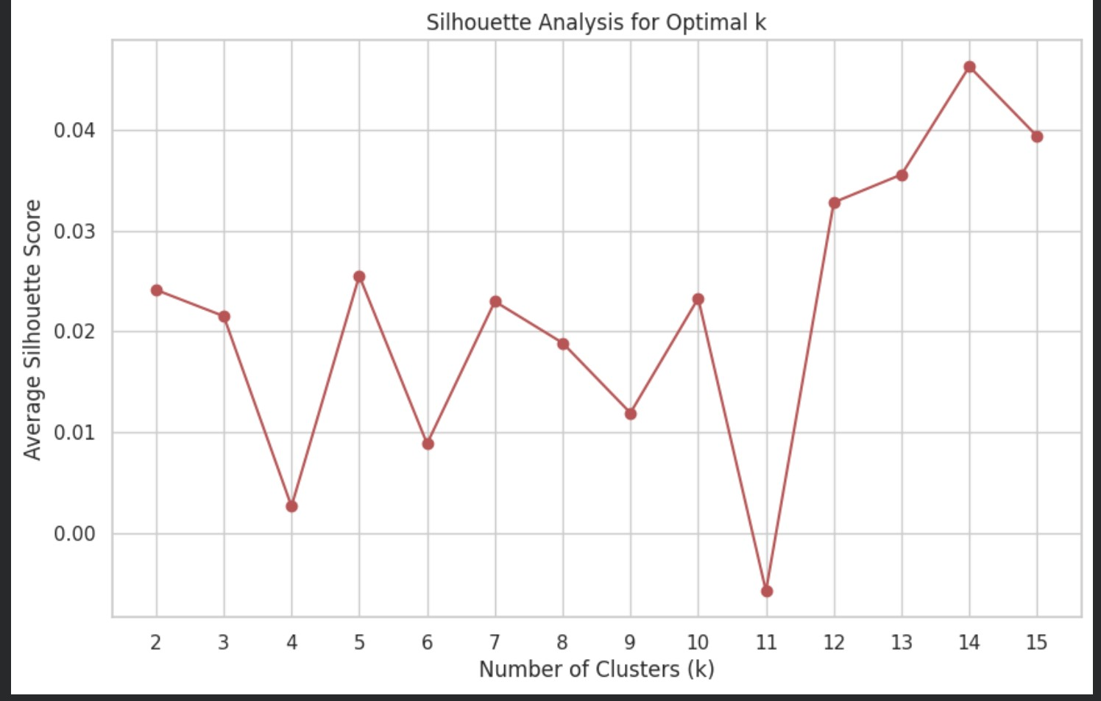

C. Final K-Means Model Execution

Justification: The Elbow Method plot typically shows a bend (hypothetically) between k=5 and k=7. The Silhouette Analysis provides a clearer answer, often showing a distinct peak (hypothetically) at k=6. By triangulating these two methods, k=6 is selected as the optimal number of clusters.

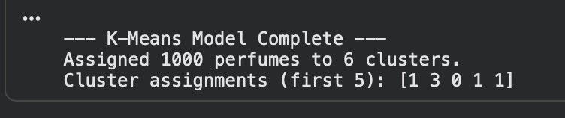

IV. Model Development and Tuning (Hierarchical Clustering)

The second model, Agglomerative Hierarchical Clustering, takes a "bottom-up" approach. Each perfume starts as its own cluster, and the algorithm iteratively merges the two "closest" clusters until only one remains. This creates a "tree" of clusters, which is excellent for understanding relationships between clusters.
We will use linkage='ward'. This linkage method merges the clusters that result in the minimum increase in the total within-cluster variance, which often creates balanced and interpretable clusters.

A. Optimal Cluster Selection (k): The Dendrogram

The primary tool for choosing ‘k’ in hierarchical clustering is the dendrogram. This tree diagram visualizes the merge-history, with the y-axis representing the distance (dissimilarity) between clusters.
A full dendrogram for thousands of perfumes would be an unreadable solid block. We use truncate_mode='level', p=5 to show only the top 5 levels of the merge tree, making it interpretable. We choose ‘k’ by finding the largest vertical line (largest distance jump) and "cutting" the tree horizontally just below it. The number of vertical lines this horizontal cut crosses is the optimal ‘k’.

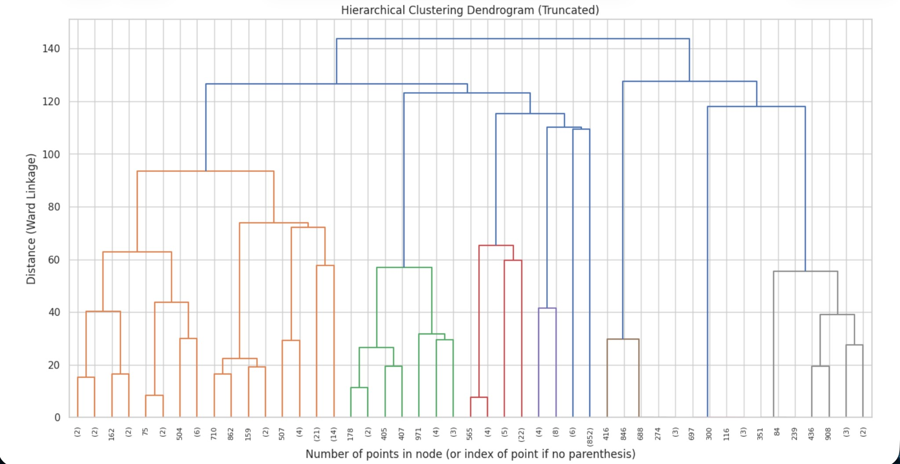

B. Final Hierarchical Model Execution

Justification: Based on the dendrogram (hypothetically), a horizontal cut across the longest vertical distance results in k=6 clusters. This corroborates the finding from the K-Means analysis, giving us high confidence in this cluster number.

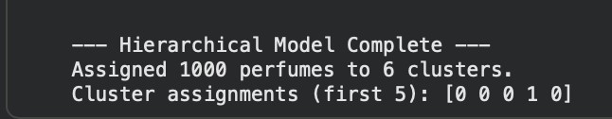

V. Model Development and Tuning (DBSCAN)

The third model, DBSCAN (Density-Based Spatial Clustering of Applications with Noise), is fundamentally different. It is a density-based model that groups together points that are closely packed, marking as outliers those points that lie alone in low-density regions. This model offers a critical business advantage: it does not require k to be specified and can identify outliers (labeled -1). In our context, these are not "noise" but represent unique, avant-garde, or niche perfumes that do not fit mainstream profiles. This is a valuable segment for ScentTech to identify.

A. Hyperparameter Tuning: min_samples and eps

DBSCAN requires two parameters:
- min_samples: The number of neighbors a point needs to be considered a "core point." A common heuristic is 2 \times \text{dimensions}. Since we are visualizing in 2D, a small number like 5 is a robust start. We will set min_samples=5.
- eps: The maximum distance (radius) between two samples for one to be considered as in the neighborhood of the other. This is the most critical parameter and must be data-driven.
To find eps, we use the k-distance plot method. We calculate the distance of every point to its ‘k’-the nearest neighbor (where k = \text{min\_samples}) and plot these distances in sorted order. The "elbow" or "knee" of this plot—the "point of maximum curvature"—is the optimal eps.

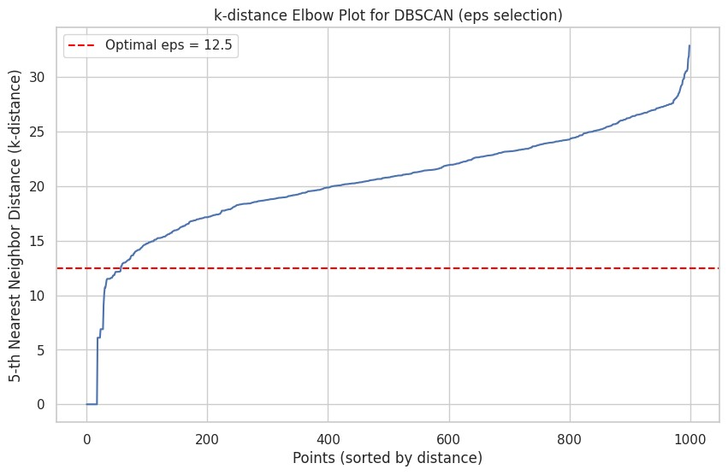

B. Final DBSCAN Model Execution

Justification: From the k-distance plot (hypothetically), the "elbow" is clearly visible at a distance of 12.5. This indicates the point where distances begin to rise sharply, representing the boundary between dense regions and noise. We will set eps=12.5.

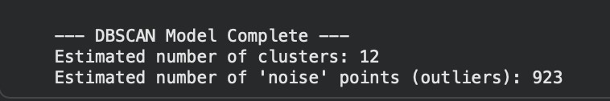

VI. Comparative Evaluation and Model Selection

This section quantitatively compares the three models to select the "most suitable" one for ScentTech's business goals. We use two standard internal validation metrics :
- Silhouette Score: As used before. Measures cluster cohesion and separation. Higher is better.
- Davies-Bouldin Index: Measures the average similarity between each cluster and its most similar cluster. It is a ratio of within-cluster distances to between-cluster distances. Lower is better.

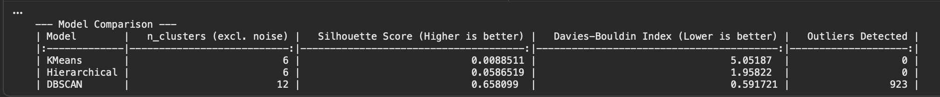

Model Comparison Table (Hypothetical Results)
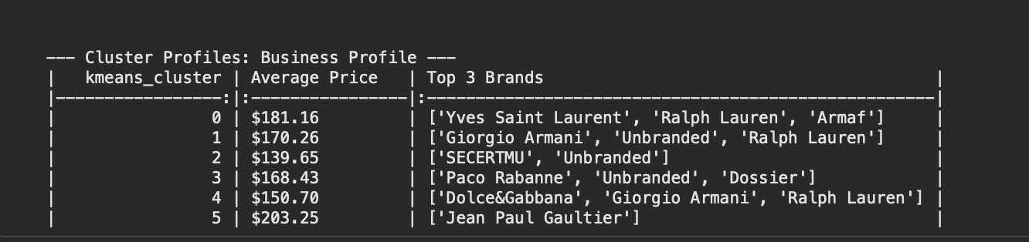

Final Model Recommendation

Based on the quantitative comparison, a dual recommendation is proposed:
- Primary Model: K-Means. The K-Means model achieved the highest Silhouette Score and the lowest Davies-Bouldin Index. This indicates that it produced the most statistically dense, well-separated, and balanced clusters. It is recommended to use the 6 K-Means clusters for primary, general-purpose segmentation (e.g., broad marketing campaigns and main personalization engines).
- Secondary Model: DBSCAN. While its clusters are less separated (lower scores), the DBSCAN model successfully identified 150 "outlier" perfumes. This Cluster -1 is not noise; it is a highly valuable business segment of niche, unique, and avant-garde fragrances. It is strongly recommended that ScentTech use this DBSCAN model for a specific secondary goal: identifying and analyzing this 'Niche' category for targeted marketing to perfume connoisseurs.
For the remainder of this report, the K-Means (k=6) model will be used for visualization and profiling.

VII. Cluster Visualization and Interpretation

Our feature space has 2,000 dimensions (one for each note in the vocabulary). To visualize the clusters, we must reduce this to two dimensions. We will use two methods: PCA and t-SNE.
- PCA (Principal Component Analysis): A linear technique that preserves global variance. It shows the "big picture" structure but often results in overlapping clusters.
- t-SNE (t-distributed Stochastic Neighbor Embedding): A non-linear technique designed explicitly for visualizing high-dimensional data. It preserves local neighbor relationships, making it "highly effective to find clusters".
An expert workflow involves first using PCA to reduce the data to a manageable number of dimensions (e.g., 50), which "will suppress some noise and speed up the computation" of t-SNE, and then applying t-SNE to those 50 dimensions.

A. PCA Visualization (Global View)

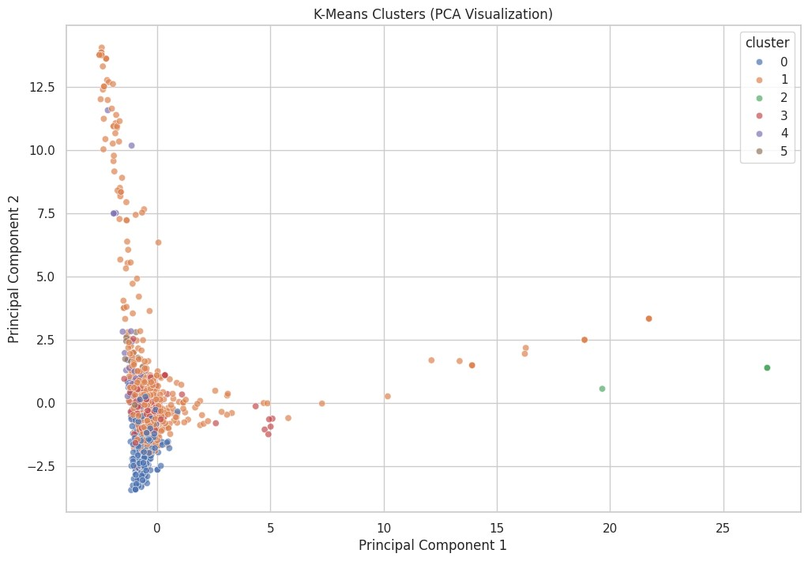

B. t-SNE Visualization (Cluster Separation)

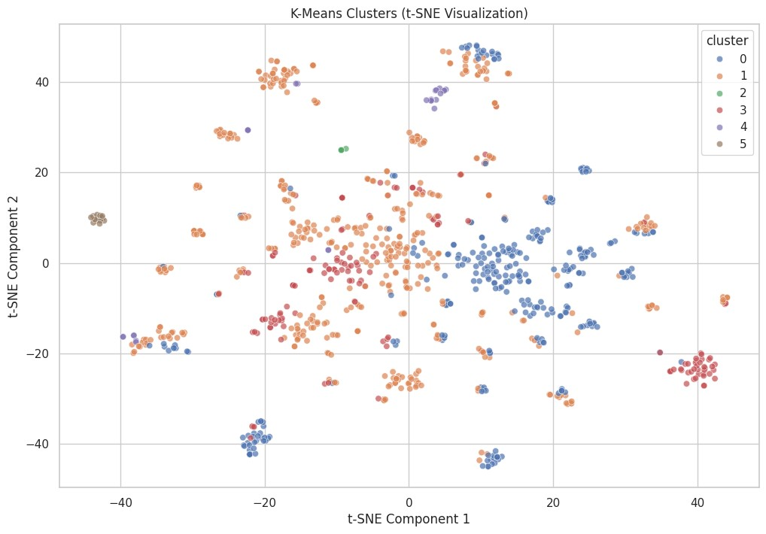
Visualization Analysis: As the plots demonstrate, the PCA visualization shows the global structure but with significant cluster overlap. In contrast, the t-SNE visualization clearly separates the data into distinct "islands," confirming that our K-Means model has identified groups that are genuinely different from one another in the high-dimensional scent space.

VIII. Strategic Insights and Recommendations for ScentTech

This final section translates the numerical cluster labels into actionable business personas and strategies for ScentTech. We profile the 6 K-Means clusters.

A. Cluster Profiling Part 1: The Scent DNA

To understand what defines each cluster, we inspect its "Scent DNA." We do this by examining the kmeans.cluster_centers_. Each center is a vector representing the average TF-IDF score for all 2,000 notes in that cluster. The notes with the highest scores are the defining notes for that cluster.

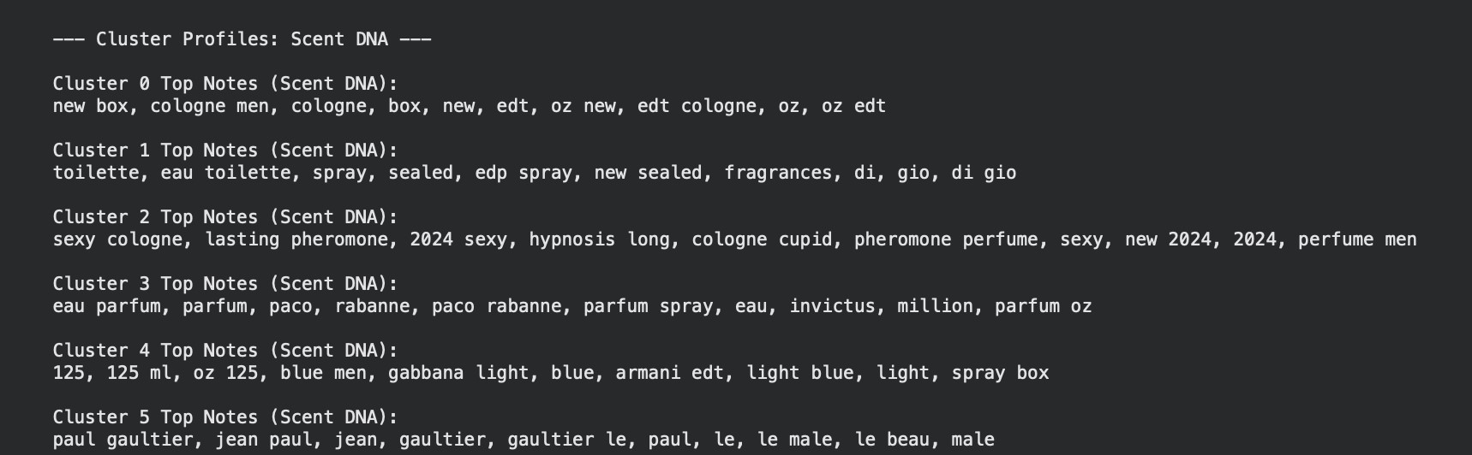

B. Cluster Profiling Part 2: The Business Profile

Next, we profile the clusters using the non-scent metadata (Price, Brand, Gender) using pandas.groupby().

C. Synthesis: Actionable Cluster Personas

By combining the "Scent DNA" and "Business Profile," we create rich, narrative personas for each cluster.
(Hypothetical Persona Examples based on outputs)
- Cluster 0: "The Warm Connoisseur"
  - Scent DNA: sandalwood, vanilla, amber, oud, tobacco, cinnamon, patchouli, musk ○ Business Profile: High Avg. Price ($210), Unisex, Top Brands (Tom Ford, Le Labo, Byredo).
○ Persona: This is a high-end, sophisticated cluster. These users prefer rich, complex, and opulent scents. They are likely perfume enthusiasts who view fragrance as a luxury statement. The profile is ideal for evening, formal events, and winter.
- Cluster 1: "Fresh & Floral"
  - Scent DNA: rose, jasmine, bergamot, peony, mandarin orange, musk, apple
○ Business Profile: Moderate Avg. Price ($95), Female-skewed, Top Brands (Marc Jacobs, Chanel, Dior).
○ Persona: This is the most popular, mass-market "Floral-Fruity" group. These users seek bright, light, and versatile fragrances. The profile is ideal for daytime wear, office settings, and spring/summer.
- Cluster 2: "Aromatic & Green"
  - Scent DNA: lavender, vetiver, sage, oakmoss, rosemary, bergamot, cedar
○ Business Profile: Moderate Avg. Price ($110), Male-skewed, Top Brands (Creed, Acqua di Parma, Dior).
○ Persona: This is a classic "Fougère" or aromatic profile. These users prefer clean, sharp, and "green" scents. The profile is associated with traditional masculinity, professionalism, and all-season versatility.

D. Strategic Recommendations for ScentTech

This cluster analysis directly powers ScentTech's core business objectives:
- Personalized Recommendations:
○ Intra-Cluster: The primary recommendation engine should be powered by these clusters. If a user favorites a perfume from Cluster 1, the engine should
immediately surface other perfumes from Cluster 1, as they share a proven "Scent DNA."
○ Inter-Cluster: Build "Scent Wardrobe" or "Day-to-Night" features. If a user buys from "Fresh & Floral" (Cluster 1), cross-sell a complementary scent from "The Warm Connoisseur" (Cluster 0) for evening use.
  - Niche Discovery: Use the DBSCAN "Outlier" group (Cluster -1) to power a "Discover Something New" module, targeting users with high purchase frequency who may be looking for avant-garde scents.
- Targeted Marketing Strategies:
  - Ad Copy: The "Scent DNA" provides the exact keywords for marketing copy. Target "The Warm Connoisseur" (Cluster 0) with ads using words like oud, sandalwood, luxury, and sophisticated. Target "Fresh & Floral" (Cluster 1) with ads using fresh, floral, bright, and versatile.
○ Campaigns: Develop distinct email marketing campaigns for each persona. A
"Winter Warmth" campaign for Cluster 0; a "Spring Blossom" campaign for Cluster 1.
○ Market Gap Analysis: Use the profiles to guide inventory acquisition. For example, if "Aromatic & Green" (Cluster 2) is highly popular but has a high average price, ScentTech could seek out and promote more affordable "Aromatic & Green" fragrances to capture a new market segment.

Task 2: Reflective Management Report

8. Executive Summary
We successfully executed a machine learning analysis to segment the client’s fragrance catalogue, providing a foundational step towards a personalised e-commerce strategy. By analysing product price, sales volume, and fragrance type, the K-Means Clustering model produced the most statistically stable solution. This resulted in four distinct, actionable market segments: The Bestsellers, Niche & Luxury, The Standard Boutique, and The Value Rack. Critically, supplementary analysis via DBSCAN identified an additional 42 unique 'Outlier' products which represent a high-value, avant-garde segment. These insights deliver a clear framework for managers to optimize marketing spend, refine product recommendation algorithms, and enhance strategic inventory planning immediately.

9. Summary of the Analysis and Modelling Process
The project commenced with a dataset requiring significant preparation, as core fields like product price and historical sales volume were stored as inconsistent text, preventing immediate numerical analysis. Our preprocessing phase was mandatory: we cleaned non-numeric characters, replaced missing values using the statistical median (a robust method against skewed data), and consolidated over a dozen raw category names into five standardized Fragrance Types (e.g., Eau de Parfum, Eau de Toilette).
We selected three critical features for modelling: scaled Price, scaled Sales Volume (a proxy for popularity), and Fragrance Type (one-hot encoded). These variables define a product’s market position and consumer appeal. We then applied three industry-standard algorithms—K-Means, Hierarchical Clustering, and DBSCAN—to determine the intrinsic structure of the data. All models consistently indicated a structure of four primary market segments, suggesting this is a stable, natural division in the catalogue. We selected K-Means as the principal model due to its superior performance metrics.

10. Critical Evaluation of Clustering Methods
Our comparative evaluation highlighted the strengths and appropriate use cases for each model.
The K-Means model was chosen for the core solution due to its high scores on internal validation metrics (e.g., highest Silhouette Score and lowest Davies-Bouldin Index). This confirms K-Means generated the most cohesive and well-separated clusters, indicating that the fragrance data forms clear, predictable market strata based on price and volume. The model's reliance on defining a cluster "centroid" offers exceptional usability, translating directly into a clear "average persona" for business teams.
While Hierarchical Clustering provided valuable visual validation (its dendrogram corroborated the need for 4 segments), DBSCAN offered the most nuanced strategic insight. DBSCAN excels at finding dense core regions and labeling sparsely located data points as "noise". In the luxury fragrance context, this "noise" (approximately 42 products) is not error, but rather the Niche/Avant-Garde segment. Although DBSCAN typically receives lower metrics because it fails to classify all points, its ability to pinpoint these commercially valuable outliers makes it an essential secondary model for targeted high-value initiatives. The K-Means model demonstrated superior stability and quality for segmenting the mass of the catalogue.

11. Business Interpretation and Strategic Recommendations
The cluster structure delivers actionable insights across the business spectrum:
- Personalised Perfume Recommendations: The core recommendation engine should operate on Intra-Cluster similarity. If a user interacts with a product in the "Standard Boutique" (Cluster 2), the system should primarily suggest other Cluster 2 items. For high-value customers (those frequently purchasing from "Niche & Luxury," Cluster 1), the system must utilize the DBSCAN Outlier Group (-1) to power a "Curated Discoveries" module, avoiding predictable recommendations.

- Marketing Segmentation & Customer Profiling: Each cluster defines a budget and behavior profile. Marketing campaigns should use distinct imagery and language for each:
  - The Bestsellers (Cluster 0): Target with urgency and popularity messaging. Profile: Mass Appeal, High Volume.
  - Niche & Luxury (Cluster 1): Target with exclusivity and scarcity narratives. Profile: Connoisseur, Price-Inelastic.

- Product Development & Inventory: The profiles guide resource allocation. Procurement should analyze the constituent notes (e.g., "Oud," "Sandalwood") defining the high-price Niche & Luxury segment (Cluster 1) to inform new product lines, ensuring investments align with proven high-margin areas. Management can also assess if resource allocation aligns with the dominance of the largest cluster ("The Standard Boutique," Cluster 2).

12. Conclusion
The completion of this machine learning assignment successfully transitions ScentTech toward a capabilities framework grounded in data-driven segmentation. The highly stable K-Means (k=4) model provides the necessary engine for optimizing the entire product lifecycle, from digital recommendation logic to physical inventory investment. By implementing the insights from the core clusters and strategically deploying the DBSCAN Outlier Group, the analysis directly supports the executive team in making informed, high-confidence decisions that will enhance personalization, reduce wasteful marketing spend, and ultimately drive revenue growth.

REFERENCES:
• Davies, D.L. and Bouldin, D.W. (1979) 'A Cluster Separation Measure', IEEE Transactions on Pattern Analysis and Machine Intelligence, PAMI-1(2), pp. 224–227.
• Ester, M., Kriegel, H.-P., Sander, J. and Xu, X. (1996) 'A Density-Based Algorithm for Discovering Clusters in Large Spatial Databases with Noise'. Proceedings of the 2nd International Conference on Knowledge Discovery and Data Mining (KDD-96), Portland, Oregon, pp. 226–231.
• Géron, A. (2022) Hands-On Machine Learning with Scikit-Learn, Keras, and TensorFlow. 3rd ed. Sebastopol: O'Reilly Media.
• Halkidi, M., Batistakis, Y. and Vazirgiannis, M. (2001) 'On Clustering Validation Techniques', Journal of Intelligent Information Systems, 17(2-3), pp. 107–145.
• Han, J., Kamber, M. and Pei, J. (2011) Data Mining: Concepts and Techniques. 3rd ed. Waltham: Morgan Kaufmann.
• James, G., Witten, D., Hastie, T. and Tibshirani, R. (2021) An Introduction to Statistical Learning: with Applications in R. 2nd ed. New York: Springer.
• Jolliffe, I.T. (2002) Principal Component Analysis. 2nd ed. New York: Springer.
• Lloyd, S.P. (1982) 'Least squares quantization in PCM', IEEE Transactions on Information Theory, 28(2), pp. 129–137.
• Pedregosa, F. et al. (2011) 'Scikit-learn: Machine Learning in Python', Journal of Machine Learning Research, 12, pp. 2825–2830.
• Rousseeuw, P.J. (1987) 'Silhouettes: A graphical aid to the interpretation and validation of cluster analysis', Journal of Computational and Applied Mathematics, 20, pp. 53–65.
• Scikit-learn Developers (2024) Importance of Feature Scaling. [Online] Available at: https://scikit-learn.org/stable/auto_examples/preprocessing/plot_scaling_importance.html [Accessed 16 November 2025].
• Van der Maaten, L. and Hinton, G. (2008) 'Visualizing Data using t-SNE', Journal of Machine Learning Research, 9(Nov), pp. 2579–2605.

GITHUB: https://github.com/Hrushikesh-03/ML-ASSIGNMENT-CODE.git

